**Percentile Assignment**

* The dataset is based on “Placement” of MBA Student dataset.
* Based on the dataset can able to analyze about the range of data exist in dataset.

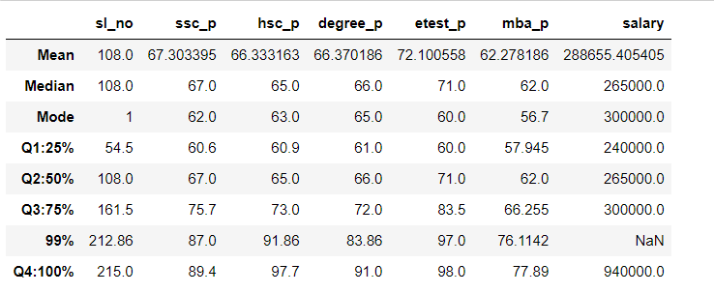

* The above screenshot shows the student percentile of SSC, HSC, Degree, Entrance, MBA Pass score and salary of the student.
* In SSC pass – 25% of student got 60.6 marks, 50% of student got 67.0 marks, 75% of student got 75.7 marks, 99% of student got 87.0 marks, 100% of student got 89.4 marks.
* In HSC pass – 25% of student got 60.9 marks, 50% of student got 65.0 marks, 75% of student got 73.0 marks, 99% of student got 91.86 marks, 100% of student got 97.7 marks.
* In Degree pass – 25% of student got 61.0 marks, 50% of student got 66.0 marks, 75% of student got 72 marks, 99% of student got 83.86 marks, 100% of student got 91.0 marks.
* In Entrance pass – 25% of student got 60 marks, 50% of student got 71 marks, 75% of student got 83.5 marks, 99% of student got 97.0 marks, 100% of student got 98.0 marks.
* In MBA pass – 25% of student got 57.945 marks, 50% of student got 62 marks, 75% of student got 66.255 marks, 99% of student got 76.1142 marks, 100% of student got 77.89 marks.
* In Salary – 25% of student got 240000 salary, 50% of student got 265000 salary, 75% of student got 300000 salary, 99% of student got NAN (due to nan value in dataset), 100% of student got 940000 salary.